
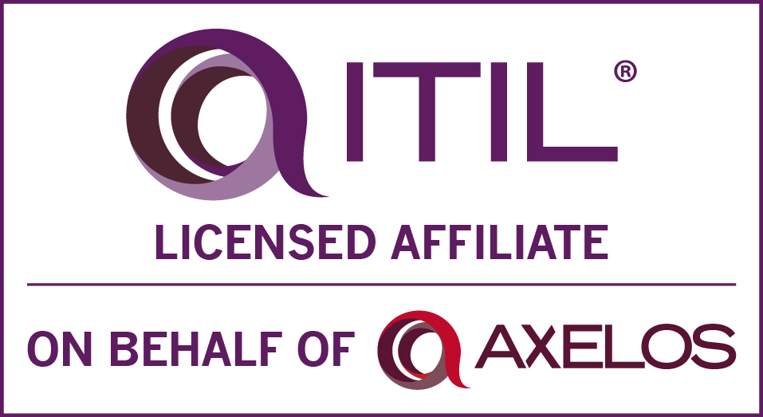
Nilesh Mahendra Vargaonkar
SharePoint Administrator with 8+ years of expertise
E-mail Id: nileshmv@gmail.com
Contact No. : +91 99 70 666230
Address: A-405, Aishwaryam Akurdi, Near Khandoba Mandir, Akurdi-411019,Pune.

PROFESSIONAL EXPERIENCE [Total Experience: 8 years and 2 months]

- 7 Years and 2 months of experience in Microsoft Office SharePoint as a SharePoint Administrator 2010 and 2013.
- Requirements gathering and analysis, Documentation, Planning and Implementation for SharePoint 2013.
- Understanding of multiple access and authentication models such as NTLM, ADFS, and SSL.
- Participate in Architectural Peer Review activities with other Groups (DBA / AD / Legal Team etc.,)
- Define the Service Applications Architecture and make sure that there is NO SPoF (Single Point of Failure)
- SharePoint 2013 hosted on Windows Azure Platform.
- SharePoint 2013 collaboration with Active Directory Federation Services (ADFS).
- SharePoint 2013 Database hosted on a three node cluster with High Availability.
- Configured Office Web Application for SharePoint 2013.
- Experience in leading the team, as a Module Leader.
- Good Experience in SharePoint Workflows 2010
- Good Experience in SharePoint InfoPath Forms 2010
- SharePoint Administrator with a broad range of IT Technologies and expertise in administrating internet, intranet and extranet based websites using SharePoint Technologies.
- Working Experience in 24*7 support and Production Support.
- Extensive knowledge and hands-on experience in administering and managing SharePoint Server 2010 and SharePoint 2013.
- Experience in configuring and working with Service Applications in SharePoint Server2010 and SharePoint 2013.
- Good experience in configuring and deploying packages and solutions in the SharePoint farm.
- Good experience in SharePoint Server 2010 and SharePoint 2013, can work effectively with Web parts/Apps, Document Libraries, List Libraries and Excel.
- Experience in SharePoint Features and Content Types.
- Good experience in Search Configuration.
- Experience in Backup and Restore of the SharePoint Sites.
- Good Experience in STSADM and PowerShell commands Tools.
- Expertise in migrations from SharePoint 2007 to SharePoint 2010 farms using third party tool as well as powershell.
- Operational acquaintance with Microsoft SharePoint 2007/2010/2013.
- Exposure to Microsoft SharePoint Designer 2010/2013, Microsoft Visual Studio 2005, Metallogix Migration Manager, SQL Management Studio.
- Experienced as operating effectively with varying priorities and threat/risk.
- Verified capability to be trained and familiarize to latest technologies plus features.
- Initiative-taker, an effective communicator with excellent relationship building & interpersonal skills.
TECHNICAL EXPERIENCE

- Working as a Technical Lead for SharePoint Administrator Project in Tech Mahindra Ltd., Pune from 7th October 2016 to Till Date.
- Worked as a SharePoint Administrator (Level 3)/ SharePoint Architect in L&T InfoTech Pvt. Ltd., Pune from 30th March 2015 to 30th September 2016.
- Worked as a SharePoint Administrator (Level 2) in Tata Consultancy Services Ltd., Pune from 24th Sept 2014 to 26th March 2015.
- Worked as a SharePoint Administrator (Level 2) in Cognizant Technology Solutions Pvt. Ltd., Pune from 30th Aug 2010 to 11th Sept. 2014.
TECHNICAL SKILLS

- Primary Skills : MS SharePoint 2010/2013 Admin.
- Programming Languages : ASP .Net 2.0/4.0, HTML, XML
- Web Technologies : MS SharePoint 2007/2010/2013
- IDE : Microsoft Visual Studio 2005/2010, SQL Server
Management Studio 2008, MS SharePoint
Designer, Metallogix Migration Manager.
- Database : SQL Server with High Availability.
CERTIFICATIONS

- ITILv3 Foundation for Service Management by Axelos
- IKM (International Knowledge Management) Certification for SharePoint 2013 Administration
- 70-573: MS SharePoint: Application Development

PROFESSIONAL EXPERIENCE

- Project#1

- Name KPN IT4IT SharePoint Support
- Client KPN
- Period Oct 2016 to Till Date
- Role SharePoint Administrator
- Team Size 5
- Environment MS SharePoint 2010, InfoPath Designer
SQL Server 2008 R2, Service Now for ticketing System, JIRA for User Stories.
- Description
This is a support project for KPN (Largest Telecom Organization in Netherland) in which we are providing support of SharePoint FIEP Application which is having lot of Custom InfoPath forms along with the data connections into it for fetching the data, also there are lot many workflows associated with the lists which are interconnected. In this project I worked as a MS SharePoint 2010 Admin, SharePoint Online Administrator and SharePoint Designer.

- Project#2

- Name Taylor Level3 SharePoint Support
- Client United Technologies Corporation
- Period Mar 2015 to Till Date
- Role SharePoint Administrator
- Team Size 2
- Environment MS SharePoint 2013, ADFS, JBOSS, .NET, Adobe Connect
SQL Server 2008 R2, ITSM Remedy Incident Management, Service Desk
- Description
This is a support project for United Technologies Corporation in which we are providing support of SharePoint farm along with other Applications hosted on .Net, JBoss, and on top of all the applications, ADFS for Authentication of all the Applications. In this project I worked as a MS SharePoint 2013 Admin. In this project we were providing support to the SharePoint farms and all the applications hosted on multiple technologies, SharePoint SQL Database Environment with High Availability, ADFS Farm with redundancy.

- Project#3

- Name BP_E&P ECM GDMP Spprt Off Pune
- Client British Petroleum
- Period Sept. 2014 to Mar. 2015
- Role SharePoint Administrator
- Team Size 15
- Environment MS Sharepoint 2010, MS Sharepoint 2013, SQL Server 2008
R2, ITSM Remedy Incident Management.
- Description
This is a support project for British Petroleum in which we are providing support of SharePoint farm. In this project I worked as a MS Sharepoint 2010 and 2013 Admin”. In this project we were providing support to the sharepoint farms

- Project#4

- Name TIS GSO L1 Support
- Client Credit Suisse Banking Group
- Period June 2013 to Sept. 2014
- Role SharePoint Administrator
- Team Size 17
- Environment MS Sharepoint 2010, SQL Server 2008 R2, ITSM Remedy
Incident Management, Service NOW for Change Requests.
- Description
This is a L1 support project for Credit-Suisse in which we were providing support of various technologies such as WebLogic, Iplanet, SharePoint and many more. In this project I worked as a MS Sharepoint 2010 Admin”. In this project we were providing support to the sharepoint sites of three regions (Singapore, New York and London).

- Project#5

- Name Merck ECCE SP2010 Migration
- Client MERCK
- Period Jan 2011 to May 2013
- Role (a) Migration Analyst, (b) Issue Resolution Team Member,
(c) Verification and Testing team member
- Team Size 20
- Technologies MS Sharepoint, Powershell.
- Description
This was a migration project in which we used to migrate the MS Sharepoint 2007” sites to MS Sharepoint 2010”. In this project we used Metallogix Migration Manager” for the migration purpose of these sites. Also we learned how to resolve various issues during migration.

EDUCATIONAL QUALIFICATION

- B.Tech. in Electronics & Tele-Communications (2006-10) from Dr. Babasaheb Ambedkar Technological University, Lonere.

EXAMINATION | BOARD\UNIVERSITY | YEAR | AGGREGATE
B.Tech. (Electronics & Tele- Communication) | Dr. B. A. T. U., Lonere. | 2010 | 6.52 (CGPA)
XII | Mumbai Board | 2006 | 79.50%
X | Mumbai Board | 2004 | 77.73%

PERSONAL INFORMATION

Name : Nilesh Mahendra Vargaonkar
Father’s Name : Mahendra Dinanath Vargaonkar
Date of Birth : 28th March 1989
Sex : Male
Nationality : Indian
Marital Status : Unmarried
Languages Known : English, Hindi and Marathi
Passport : Available (H9843846)

